# 5G EVE – WP4 – Visualization tool for transport vertical

Summary

5G EVE – WP4 – Visualization tool for transport vertical 1

Prerequisites 2

Variables 2

Installation 2

Initial Server Setup with Ubuntu 18.04 2

Install Oracle JDK (as user5g) 2

Install NGINX (as user5g) 2

Install Elasticsearch 2

Install Kibana 3

Install Logstash 4

## Prerequisites

* OS: Linux
* Distro: Ubuntu 18.04
* RAM: 4 GB
* CPU: 2

## Variables

|  |  |
| --- | --- |
| **Name** | **Description** |
| <hostname> | Hostname or public ip address of the linux machine |

## Installation

### Initial Server Setup with Ubuntu 18.04

**Login as root**

$ ssh root@<hostname>

**Creating new user**

$ adduser user5g

**Granting Administrative Privileges**

$ usermod -aG sudo user5g

**Setting Up a Basic Firewall**

$ ufw allow OpenSSH

$ ufw enable

### Install Oracle JDK (as user5g)

$ sudo add-apt-repository ppa:webupd8team/java

$ sudo apt update

$ sudo apt install oracle-java8-installer

### Install NGINX (as user5g)

$ sudo apt update

$ sudo apt install nginx

$ sudo ufw allow 'Nginx HTTP'

### Install Elasticsearch

**Import the Elasticsearch public GPG key into APT**

$ wget -qO - https://artifacts.elastic.co/GPG-KEY-elasticsearch | sudo apt-key add -

**Add the Elastic source list to the sources.list.d directory,**

$ echo "deb https://artifacts.elastic.co/packages/6.x/apt stable main" | sudo tee -a /etc/apt/sources.list.d/elastic-6.x.list

**Update your package lists**

$ sudo apt update

**Install Elasticsearch**

$ sudo apt install elasticsearch

**Change Elasticsearch Configuration**

$ sudo nano /etc/elasticsearch/elasticsearch.yml

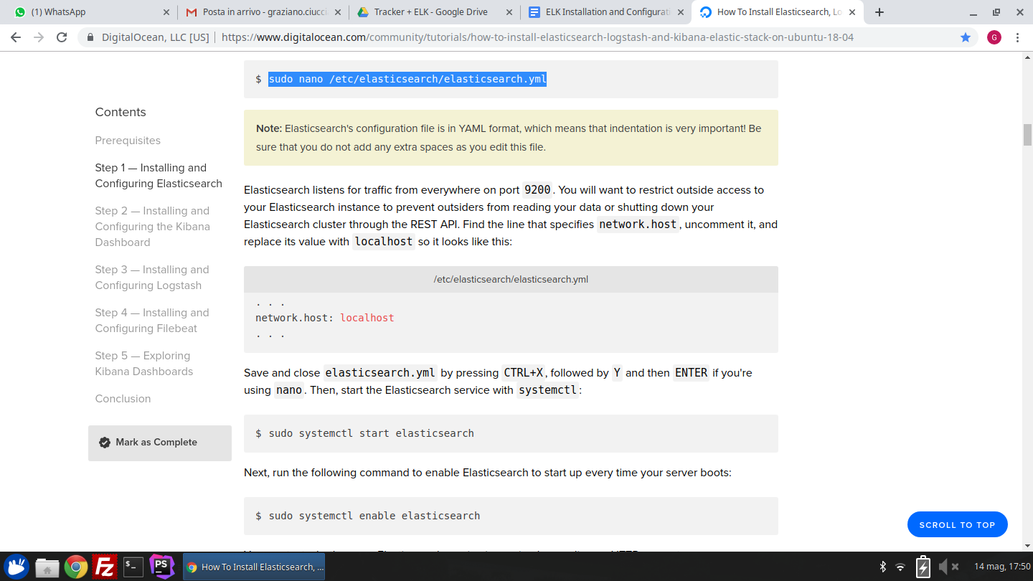

**Start the Elasticsearch service**

$ sudo systemctl start elasticsearch

**Enable Elasticsearch**

$ sudo systemctl enable elasticsearch

### Install Kibana

**Install Kibana**

$ sudo apt install kibana

**Enable and Start Kibana**

$ sudo systemctl enable kibana

$ sudo systemctl start kibana

**Create the administrative Kibana user and password**

$ echo "kibanaadmin:`openssl passwd -apr1`" | sudo tee -a /etc/nginx/htpasswd.users

**Direct your server's HTTP traffic to the Kibana application and configures Nginx to read the htpasswd.users**

$ sudo nano /etc/nginx/sites-available/5geve

server {

listen 80;

server_name <hostname>;

auth_basic "Restricted Access";

auth_basic_user_file /etc/nginx/htpasswd.users;

location / {

proxy_pass http://localhost:5601;

proxy_http_version 1.1;

proxy_set_header Upgrade $http_upgrade;

proxy_set_header Connection 'upgrade';

proxy_set_header Host $host;

proxy_cache_bypass $http_upgrade;

}

}

**Enable the new configuration by creating a symbolic link to the sites-enabled directory**

$ sudo ln -s /etc/nginx/sites-available/5geve /etc/nginx/sites-enabled/5geve

**Restart the Nginx service**

$ sudo systemctl restart nginx

**Allow connections to Nginx**

$ sudo ufw allow 'Nginx Full'

### Install Logstash

**Install Logstash**

$ sudo apt install logstash

**Configure Logstash**

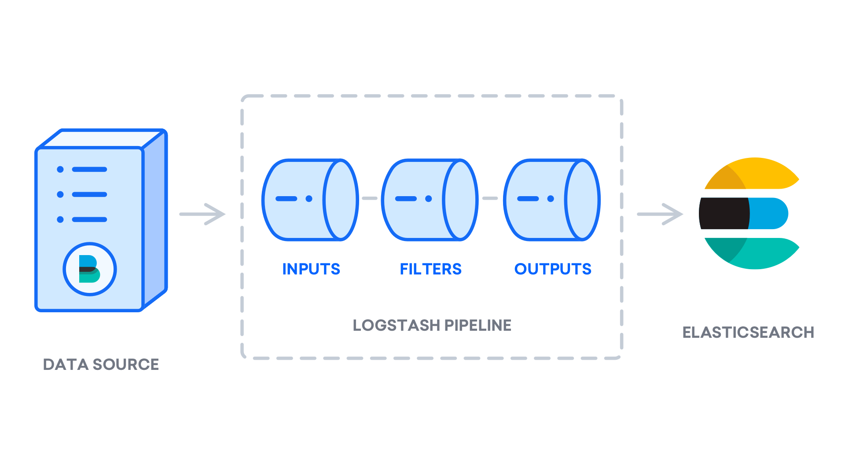

* ***Input***

$ sudo nano /etc/logstash/conf.d/02-beats-input.conf

input {

file {

type => "eve_tracker"

path => "/var/www/html/5g_eve_tracker_backend/storage/csv/devices/*/*.csv"

start_position => "beginning"

sincedb_path => "dev/null"

}

}

* ***Filter***

$ sudo nano /etc/logstash/conf.d/10-syslog-filter.conf

filter {

if [type] == "eve_tracker" {

csv {

separator => ";"

columns => [ "id", "name", "user", "timestamp", "datetime", "networkgen", "networktype", "active", "mcc", "mnc", "lac_tac", "cid_pci", "psc_ci", "rssi_rscp", "accel_x", "a$

}

date {

match => ["timestamp","UNIX_MS"]

target => “timestamp”

}

date {

match => ["gps_fixtime","UNIX_MS"]

target => “gps_fixtime”

}

mutate {convert => ["id","integer"]}

mutate {convert => ["active","boolean"]}

mutate {convert => ["mcc","integer"]}

mutate {convert => ["mnc","integer"]}

mutate {convert => ["lac_tac","integer"]}

mutate {convert => ["cid_pci","integer"]}

mutate {convert => ["psc_ci","integer"]}

mutate {convert => ["rssi_rscp","integer"]}

mutate {convert => ["accel_x","float"]}

mutate {convert => ["accel_y","float"]}

mutate {convert => ["accel_z","float"]}

mutate {convert => ["linear_x","float"]}

mutate {convert => ["linear_y","float"]}

mutate {convert => ["linear_z","float"]}

mutate {convert => ["azimuth","float"]}

mutate {convert => ["pitch","float"]}

mutate {convert => ["roll","float"]}

mutate {convert => ["gyro_x","float"]}

mutate {convert => ["gyro_y","float"]}

mutate {convert => ["gyro_z","float"]}

mutate {convert => ["magnetic_x","float"]}

mutate {convert => ["magnetic_y","float"]}

mutate {convert => ["magnetic_z","float"]}

mutate {convert => ["audio","integer"]}

mutate {convert => ["gps_lat","float"]}

mutate {convert => ["gps_lon","float"]}

mutate {rename => ["gps_lat","latitude"]}

mutate {rename => ["gps_lon","longitude"]}

mutate { rename => {"latitude" => "[location][lat]"} }

mutate { rename => {"longitude" => "[location][lon]"} }

mutate {convert => ["gps_alt","float"]}

mutate {convert => ["gps_accuracy","float"]}

mutate {convert => ["gps_bearing","float"]}

mutate {convert => ["gps_speed","float"]}

mutate {convert => ["gps_satellites","integer"]}

}

}

* ***Output***

$ sudo nano /etc/logstash/conf.d/30-elasticsearch-output.conf

output {

if [type] == "eve_tracker" {

elasticsearch {

hosts => ["localhost:9200"]

index => "5geve_tracker"

template_name => "templtracker"

}

}

}

**Start and enable Logstash**

$ sudo systemctl start logstash

$ sudo systemctl enable logstash

TEMPLATE

PUT _template/templtracker

{

"index_patterns": ["5geve_tracker*"],

"mappings": {

"doc": {

"properties": {

"@timestamp": {

"type": "date"

},

"@version": {

"type": "text",

"fields": {

"keyword": {

"type": "keyword",

"ignore_above": 256

}

}

},

"accel_x": {

"type": "float"

},

"accel_y": {

"type": "float"

},

"accel_z": {

"type": "float"

},

"active": {

"type": "boolean"

},

"audio": {

"type": "long"

},

"azimuth": {

"type": "float"

},

"cid_pci": {

"type": "long"

},

"datetime": {

"type": "text",

"fields": {

"keyword": {

"type": "keyword",

"ignore_above": 256

}

}

},

"gps_accuracy": {

"type": "float"

},

"gps_alt": {

"type": "float"

},

"gps_bearing": {

"type": "float"

},

"gps_fixtime": {

"type": "date"

},

"gps_satellites": {

"type": "long"

},

"gps_speed": {

"type": "float"

},

"gyro_x": {

"type": "float"

},

"gyro_y": {

"type": "float"

},

"gyro_z": {

"type": "float"

},

"host": {

"type": "text",

"fields": {

"keyword": {

"type": "keyword",

"ignore_above": 256

}

}

},

"id": {

"type": "long"

},

"lac_tac": {

"type": "long"

},

"linear_x": {

"type": "float"

},

"linear_y": {

"type": "float"

},

"linear_z": {

"type": "float"

},

"location": {

"type": "geo_point"

},

"magnetic_x": {

"type": "float"

},

"magnetic_y": {

"type": "float"

},

"magnetic_z": {

"type": "float"

},

"mcc": {

"type": "long"

},

"message": {

"type": "text",

"fields": {

"keyword": {

"type": "keyword",

"ignore_above": 256

}

}

},

"mnc": {

"type": "long"

},

"name": {

"type": "text",

"fields": {

"keyword": {

"type": "keyword",

"ignore_above": 256

}

}

},

"networkgen": {

"type": "text",

"fields": {

"keyword": {

"type": "keyword",

"ignore_above": 256

}

}

},

"networktype": {

"type": "text",

"fields": {

"keyword": {

"type": "keyword",

"ignore_above": 256

}

}

},

"path": {

"type": "text",

"fields": {

"keyword": {

"type": "keyword",

"ignore_above": 256

}

}

},

"pitch": {

"type": "float"

},

"psc_ci": {

"type": "long"

},

"roll": {

"type": "float"

},

"rssi_rscp": {

"type": "long"

},

"timestamp": {

"type": "date"

},

"type": {

"type": "text",

"fields": {

"keyword": {

"type": "keyword",

"ignore_above": 256

}

}

},

"user": {

"type": "text",

"fields": {

"keyword": {

"type": "keyword",

"ignore_above": 256

}

}

}

}

}

}

}